

Connected Vehicle Electronics

**Concept of Operations**

**(ConOps)**

**Enhanced Dashcam**

**Version 0.03**

**08/11/2020**

Printed Copies are UNcontrolled

***FORD MOTOR COMPANY***

***CONFIDENTIAL***

**The information contained in this document is Proprietary to Ford Motor Company. Disclosure or distribution to unauthorized persons is strictly prohibited.**

**Copyright, Ó 2016 Ford Motor Company**

**Confidential and Proprietary – Ford Motor Company**

This document contains information developed and accumulated by and for FORD MOTOR COMPANY. As such, it is a proprietary document, which, if disseminated to unauthorized persons, would provide others with restricted information, data, or procedures not otherwise available, exposing the FORD MOTOR COMPANY to potential harm.

Employees and suppliers having custody of this specification or authorized to use it must be cognizant of its proprietary nature and ensure that the information herein is not made available to unauthorized persons.

FORD MOTOR COMPANY reserves the right to protect this work as an unpublished copyrighted work in the event of an inadvertent or deliberate unauthorized publication. FORD MOTOR COMPANY also reserves its rights under copyright laws to protect this work as a published work.

This document or portions thereof shall not be distributed outside FORD MOTOR COMPANY without prior written consent. Refer all questions concerning disclosure to the author(s) or to the Forward Model Radio Section, Ford Motor Company.

# 

Contents

1 Introduction 6

1.1 Audience 6

1.2 Feature Vision 6

2 Feature Analysis 7

2.1 Motivation 7

2.2 Background Study 7

2.3 Minimum Viable Product 7

2.4 System (and customer) Use Cases 7

2.4.1 Video Loop Recording 7

2.4.2 User Sets Read-Only While Recording 8

2.4.3 Auto-Set Read-Only While Recording 8

2.4.4 Video Playback 8

2.4.5 Set/Clear Read-Only During Playback 9

2.4.6 Delete Video 9

2.4.7 Store Default Config 9

2.4.8 Display Storage Status 10

2.5 Failure Mode Scenarios 10

3 Solution Evaluation 11

3.1 Solution Options 11

3.2 Solution Recommendation 11

3.3 Assumptions 11

3.4 Constraints 11

3.5 Dependencies 11

3.6 Scope 11

3.6.1 In Scope: 11

3.6.2 Out of Scope: 11

4 Design Analysis of the Proposed Solution 12

4.1 Functional System Architecture 12

4.1.1 Ford Pass Functions list: 12

4.1.2 Ford Cloud/SDN 12

4.1.3 TCU Functions 12

4.1.4 ECG Functions list 12

4.1.5 SYNC 13

4.1.5.1 HMI Wireframes 13

4.1.5.2 Procedures 15

4.2 Functional Interface Analysis 15

4.2.1 Ford pass <-> SDN 15

4.2.2 TCU <-> ECG 15

4.2.3 SYNC <-> ECG 15

4.2.4 ECG <-> Ford Cloud 15

4.3 Data Usage Requirements 15

4.4 Message Sequence Diagram 16

4.4.1 Recording 16

4.4.2 Playback 17

4.5 System Functional Requirements 18

4.5.1 General system requirements 18

4.5.2 FordPass 18

4.5.3 Ford Cloud 18

4.5.4 TCU 18

4.5.5 ECG 18

4.5.6 SYNC 18

4.6 Impact Analysis Summary on FNV2.0 IVIC Modules 19

5 Glossary 20

6 References 21

7 Document Approval 22

Revision History

|  |  |  |  |  |
| --- | --- | --- | --- | --- |
| **Revision** | **Author** | **Description** | **Sections Affected** | **Release Date** |
| 0.01 | A. Shokry | Document created | All | 11-Aug-2020 |
| 0.02 | C. Neubeck | Document review | Up to section 3 | 11-Aug-2020 |
| 0.03 | A. Shokry | Functional Analysis | 4 | 11-Aug-2020 |
|  |  |  |  |  |

# 

# Introduction

The objective of the concept of operation (ConOps) document is to perform an initial technical analysis of the new vehicle features, evaluate solution options and provide design and solution recommendation. The technical analysis includes functional level software and interface impact analysis.

The technical analysis performed during this phase would enable the development teams to estimate the design and implementation efforts. The information can also be leveraged for developing detailed feature specifications

The focus of the technical analysis in this document is the Enhanced Dashcam feature.

Audience

Below are departments identified as the stakeholders of this feature, and can be consulted for input during the Pre-PS feature analysis

* CVP&P Feature Owner
* EESE Feature Owner
* FNV2.0 Platform Development
* Infotainment SPSS author
* R&A EESE <AR> Pre Feature Owner

Feature Vision

The Enhanced Dash Camera system allows users to capture vehicle data and video from a vehicle imaging surrounding system while driving and store the recorded data on removable on-board storage. A system comprised of up to 5 cameras which encompass traditional vehicle surrounding system and vehicle dash camera mounted behind the vehicle windshield glass without the obstruction from interior components (RVMD, Shade lines, brackets and other small trim pieces), and, the existing vehicle imager surrounding 360 exterior system without obstructions of external environment components. Based on user command, the selected cameras capture video of the exterior environment of the car at all times while driving as long as the portable available memory allows room to store files. The recorded files are available for the user as a play back on center display once the vehicle is in “Park” position. Drivers are able to configure the recording experience by Sync HMI (Dash Camera and/or any of the 360 cameras). In addition, the Enhanced Dash Camera system can allow user to select the vehicle data files to be added to the video files like GPS, vehicle speed and brake pedal pressed or not. The Date/Time and VIN are always recorded with the video files for traceability purpose.

# Feature Analysis

Motivation

Give the vehicle driver peace of mind by recording the vehicle surroundings in the background while they are driving per user settings, which could allow the user to use recorded video and vehicle data as needed.

Background Study

Minimum Viable Product

The base requirements for EDC to be enabled is:

* The 360 View cameras (on ADAS) plus the Dashcam (on AR).
* USB-2 drive plugged to SYNC port.
* SYNC 4.0 HMI screen 8, 12 or 15 inch size.

System (and customer) Use Cases

### Video Loop Recording

|  |  |
| --- | --- |
| **Actors** | ECG, ADAS/AR, SYNC, AR ECU |
| **Pre-conditions** | * The Dash Camera, 360˚ view cameras and high-end ADAS are present. * SYNC 4.0 with HMI is present. * A USB drive plugged in the SYNC port. * Vehicle is in Ignition-ON and SYNC menu is unlocked for selection (vehicle speed below threshold). |
| **Scenario Description** | * User selects the desired camera. * User selects the target USB drive. * User chooses whether to record 1, 3 or 5 minute segments. * User selects the desired vehicle data to be recorded, such as:   + Speed.   + GPS location.   + Steering angle.   + Outside temperature.   + Gas and brake pedals.   + Engine RPM.   + G-force. * User selects the video quality; resolution. * User press “Allow recording” button and triggers recording. * The vehicle continuously records video segments of the specified time for the parallel streams, until the user terminates recording. * The HMI shall display a recording indicator icon. * If the USB drive runs out of space before the user terminates recording, automatically delete the oldest files that are not marked as read-only. |
| **Post-conditions** | * The desired streams are recorded on the selected USB drive. Each video stream and vehicle data is in a separate file and has to be synchronized by date/time stamp. |
| **Interfaces** | ADAS 🡨🡪 ECG, ECG 🡨🡪 SYNC🡨🡪AR ECU |

### User Sets Read-Only While Recording

|  |  |
| --- | --- |
| **Actors** | ECG, ADAS/AR, SYNC, AR ECU |
| **Pre-conditions** | * The Dash Camera, 360˚ view cameras and high-end ADAS are present. * SYNC 4.0 with HMI is present. * A USB drive plugged in the SYNC port. * Vehicle is in Ignition-ON and SYNC menu is unlocked for selection (vehicle speed below threshold). |
| **Scenario Description** | * User drives through an important event or experienced an incidence. * User taps the icon on the HMI to protect the current video segments being recorded. * All the parallel video segments are marked read-only, so that they are not auto-deleted when recording loops. |
| **Post-conditions** | * The video files marked read-only are kept on the USB drive and are not auto-deleted by EDC. |
| **Interfaces** | ADAS 🡨🡪 ECG, ECG 🡨🡪 SYNC 🡨🡪AR ECU |

### Auto-Set Read-Only While Recording

|  |  |
| --- | --- |
| **Actors** | ECG, ADAS/AR, SYNC, AR ECU |
| **Pre-conditions** | * The Dash Camera, 360˚ view cameras and high-end ADAS are present. * SYNC 4.0 with HMI is present. * A USB drive plugged in the SYNC port. * Vehicle is in Ignition-ON. |
| **Scenario Description** | * EDC receives an indication of vehicle vibration that exceeds a certain threshold. * All the parallel video and vehicle data segments currently being recorded are marked read-only, so that they are not auto-deleted when recording loops. |
| **Post-conditions** | * The video and data files marked read-only are kept on the USB drive and are not auto-deleted by EDC. |
| **Interfaces** | ADAS 🡨🡪 ECG, ECG 🡨🡪 SYNC🡨🡪AR ECU |

### Video Playback

|  |  |
| --- | --- |
| **Actors** | ECG, SYNC |
| **Pre-conditions** | * SYNC 4.0 with HMI is present. * A USB drive plugged in the SYNC port. * Vehicle is in Ignition-ON and Parked. |
| **Scenario Description** | * User browses the video files recorded by EDC. * User selects one of the files to Playback. * The video is played on the screen overlaid with the vehicle data, such as the data and time of recording and VIN, besides the data selected by the user at recording time. * The user has soft-buttons to Delete file, Pause, Play, Fast-Forward and Rewind through the video at 2x the speed. |
| **Post-conditions** | Video playback on SYNC HMI screen will be fisheye and with good quality image. It supports 8, 12 and 15 inch display sizes |
| **Interfaces** | ECG 🡨🡪 SYNC |

### Set/Clear Read-Only During Playback

|  |  |
| --- | --- |
| **Actors** | ECG, SYNC |
| **Pre-conditions** | * SYNC 4.0 with HMI is present. * A USB drive plugged in the SYNC port. * Video files recorded by EDC are present. * Vehicle is in Ignition-ON and Parked. |
| **Scenario Description** | * User is playing-back a video in EDC. * User taps the icon on the HMI to protect/unprotect the current video. * The video is marked/unmarked read-only, according to the user choice. |
| **Post-conditions** | * The video file and correlated vehicle data file is marked/unmarked read-only. |
| **Interfaces** | ECG 🡨🡪 SYNC |

### Delete Video

|  |  |
| --- | --- |
| **Actors** | ECG, SYNC |
| **Pre-conditions** | * SYNC 4.0 with HMI is present. * A USB drive plugged in the SYNC port. * Video files recorded by EDC are present. * Vehicle is in Ignition-ON and Parked. |
| **Scenario Description** | * User browses the video files recorded by EDC. * User selects one of the files to Delete. * The video and correlated vehicle data file is removed from the USB drive even if it was read-only, and its space is released. |
| **Post-conditions** | * The selected video and related vehicle data file is deleted. |
| **Interfaces** | ECG 🡨🡪 SYNC |

### Store Default Config

|  |  |
| --- | --- |
| **Actors** | ECG, ADAS/AR, SYNC |
| **Pre-conditions** | * The Dash Camera, 360˚ view cameras and high-end ADAS are present. * SYNC 4.0 with HMI is present. * Vehicle is in Ignition-ON. |
| **Scenario Description** | * User selects the desired cameras. * User selects the target USB drive. * User chooses whether to record 1, 3 or 5 minute segments. * User selects the desired vehicle data to be recorded. * User selects the vibration settings. * User selects the video quality; resolution. * User chooses to record the supplied configs as the EDC default. * User allow to record button press. |
| **Post-conditions** | * The next times user chooses EDC recording to start automatically, it will use the default configs stored as well as allow record command. |
| **Interfaces** | ADAS 🡨🡪 ECG, ECG 🡨🡪 SYNC |

### Display Storage Status

|  |  |
| --- | --- |
| **Actors** | ECG, SYNC |
| **Pre-conditions** | * SYNC 4.0 with HMI is present. * A USB drive plugged in the SYNC port. Vehicle is in Ignition-ON and Parked. |
| **Scenario Description** | * User selects a USB drive plugged to the vehicle. * User chooses to view the storage status of the selected drive. * The storage status is displayed as follows:   + Total space: size of the USB drive.   + Free space: total free space on the USB drive.   + Archived size: total size of the files with read-only attribute under the directory of the requesting feature.   + Temporary size: total size of the files without read-only attribute under the directory of the requesting feature. |
| **Post-conditions** | None |
| **Interfaces** | ECG 🡨🡪 SYNC |

Failure Mode Scenarios

Failure mode scenarios are covered in [3].

# Solution Evaluation

Solution Options

None.

Solution Recommendation

* Develop an application on SYNC that implements the EDC functionality.
* EDC uses the Video Recording & Playback (VRP) function on SYNC to do the actual writing/reading of video streams to/from files, respectively as well as vehicle data.
* The EDC interface to/from VRP is SOA messages through ECG.
* EDC listens to the FRCC message and reads its severity level, so that it can automatically protect files as read-only if the threshold severity level is met.
* For video playback, EDC will locally establish an RTP server to which VRP will stream the selected video. EDC will display that stream on the HMI.
* EDC can directly use the services offered by VRP to;
  + Pause, Play, FF and RW in 2x speed during playback.
  + Obtain and display USB storage statistics.
  + Delete files.
  + Mark/unmark files as read-only.
  + Time stamp video and data files to allow synchronization during playback.

Assumptions

(None)

Constraints

(None)

Dependencies

* Requires ADAS that can stream videos from multiple cameras simultaneously.
* Requires ECG/VIM support of vehicle data messages
* FRCC Signal from ECG indicating the vibration severity level.
* Requires VRP to provide data/time stamp on video and data files for synchronization

Scope

### In Scope:

* Video recording of multiple video and data streams in loop mode for unlimited time.
* Playback of a single video synchronized with video data at the time.
* Auto-recording using the default config stored.

### Out of Scope:

* Recording in ignition-off.
* Video editing and rendering.
* Camera streams that are not sent over Ethernet from ECG to SYNC.
* Advanced File Management features, such as copy, move, rename, etc.
* Recording more than 5 simultaneous streams.
* Playback of multiple videos.

# Design Analysis of the Proposed Solution

Functional System Architecture



### Ford Pass Functions list:

None

### Ford Cloud/SDN

None

### TCU Functions

None

### ECG Functions list

Reuse:

* SOA Broker to forward commands and responses between EDC and VRP.

### SYNC

#### HMI Wireframes

Following are sample wireframes. The full list is provided in [2].

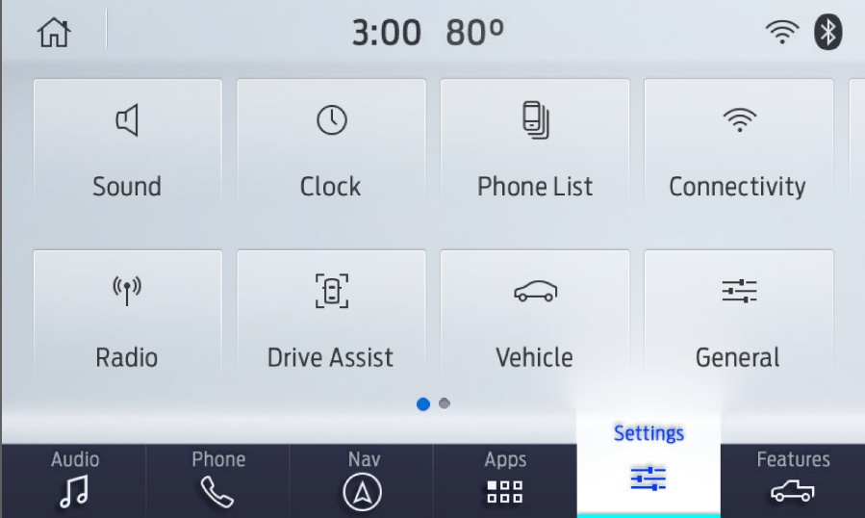

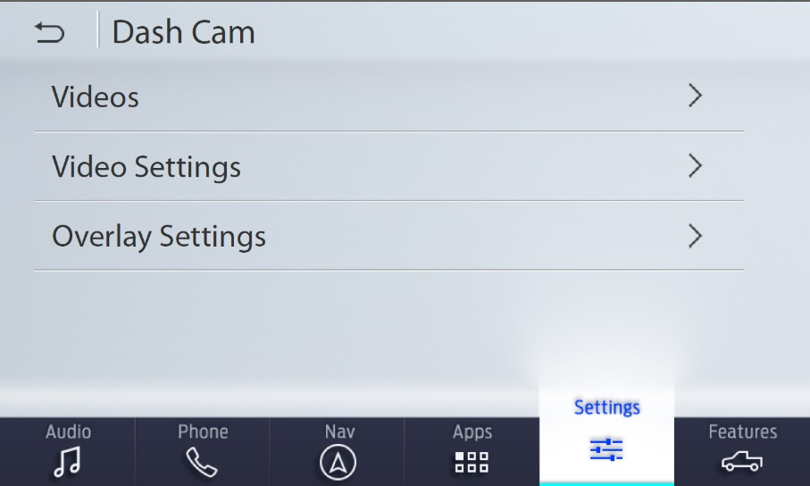

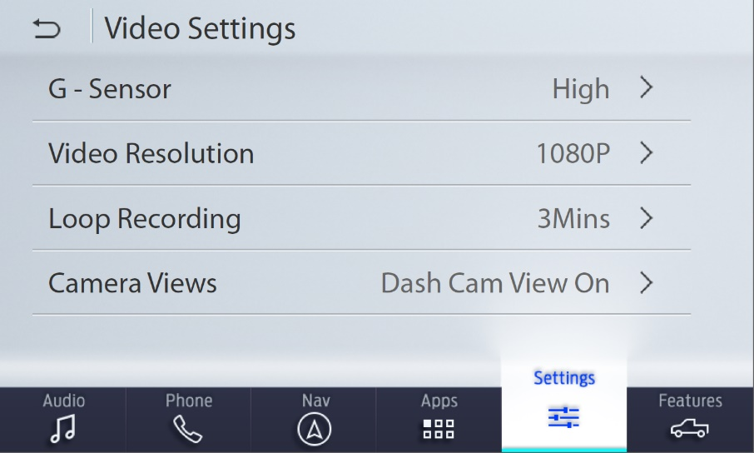

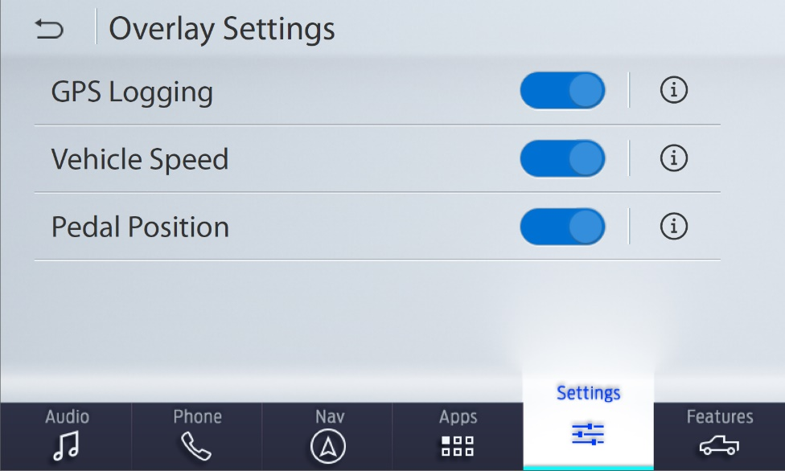

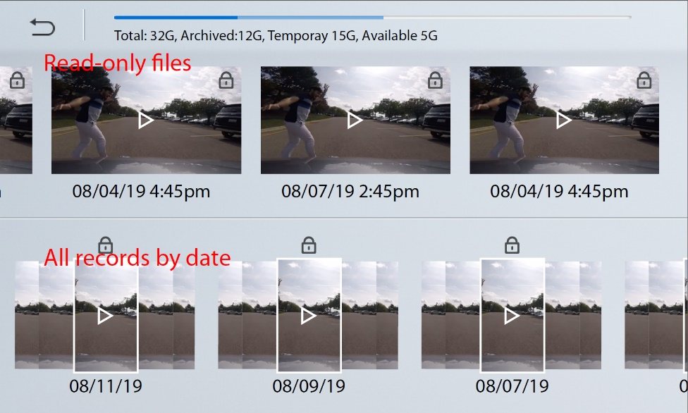

#### Procedures

Following are the procedures from a high-level for the key events. They are detailed in the FS document.

|  |  |  |
| --- | --- | --- |
| Conditions | Trigger | Procedure |
| Idle | Start Recording | * Forward the user inputs and the request to VRP. * Request VRP to publish the recording status regularly. * Display the status on the screen. |
| Idle | Save settings | * Store the default settings to be used next time for auto-recording |
| Default settings and auto-recording consent are present | Ignition turned on | * Automatically forward the default settings together with w recording request to VRP * Indicate the auto-recording by the persistent icon. |
| Recording | FRCC with severity level above threshold | * Automatically request VRP to mark all the actively being recorded files as read-only. |
| Idle | Start Playback | * Establish a local RTSP server, on which EDC will receive the playback stream. * Send the playback request to VRP. * Display the received stream on HMI. |
| *Any* | Request storage status | * Request the storage status of the selected USB drive from VRP. * Display the status summary to the user. |
| Playback | FF/RW request | * Forward the FF/RW request to VRP. * VRP will send the playback stream already in double the speed and the requested direction. * EDC displays the received stream as-is on the screen. |

Most other procedures are handled by VRP as-is

## Functional Interface Analysis

### Ford pass <-> SDN

None

### TCU <-> ECG

None

### SYNC <-> ECG

Reuse:

* The VRP API messages to provide the EDC required services, [1].

### ECG <-> Ford Cloud

None

Data Usage Requirements

None

Message Sequence Diagram

### Recording



### Playback



System Functional Requirements

### General system requirements

* ADAS with 360 View cameras.
* AR with Dashcam.
* ADAS DAT2.2 that can send up to 5 camera streams simultaneously.

### FordPass

None

### Ford Cloud

None

### TCU

None

### ECG

* Camera Manager to route the video streams from ADAS/AR to SYNC.

### SYNC

* Processing power to handle 5 simultaneous video streams.
* USB transfer speed to write 5 simultaneous video streams.

## Impact Analysis Summary on FNV2.0 IVIC Modules

|  |  |
| --- | --- |
| **Module** | **Impact Size** |
| TCU | (None) |
| ECG | XS |
| SYNC | M |

# Glossary

|  |  |
| --- | --- |
| **Acronym** | **Definition** |
| **AR** | Augmented Reality module |
| **EDC** | Enhanced Dashcam feature |
| **VRP** | Video Recording & Playback function |
|  |  |
|  |  |
|  |  |
|  |  |
|  |  |
|  |  |
|  |  |
|  |  |
|  |  |
|  |  |
|  |  |
|  |  |
|  |  |

# References

1. ConOps_VRP
2. V4.1_Wireframe191203
3. EDC DFMEA

# Document Approval

|  |  |  |  |  |
| --- | --- | --- | --- | --- |
| **Name** | **Department** | **Role** | **Email Confirmation** | **Date** |
|  |  |  |  |  |